QUESTION : 1
Create a table named Playlists with columns: id, user_id, playlist_name, and total_likes. Insert at least 8 sample rows with different users and playlists, making sure some playlists have the same user_id :
TABLE :
CREATE TABLE Playlists(
id INT,
user_id INT,
playlist_name VARCHAR(100),
total_likes INT,
PRIMARY KEY(id)
);

INSERT :
INSERT INTO Playlists(id,user_id,playlist_name,total_likes) VALUES
(1,101,'Workout hits',520),
(2,101,'Morning vibes',450),
(3,101,'Party mix',650),
(4,102,'Relax songs',700),
(5,102,'Road trip',500),
(6,103,'Study playlist',650),
(7,103,'Romantic songs',450),
(8,104,'Old classics',700);

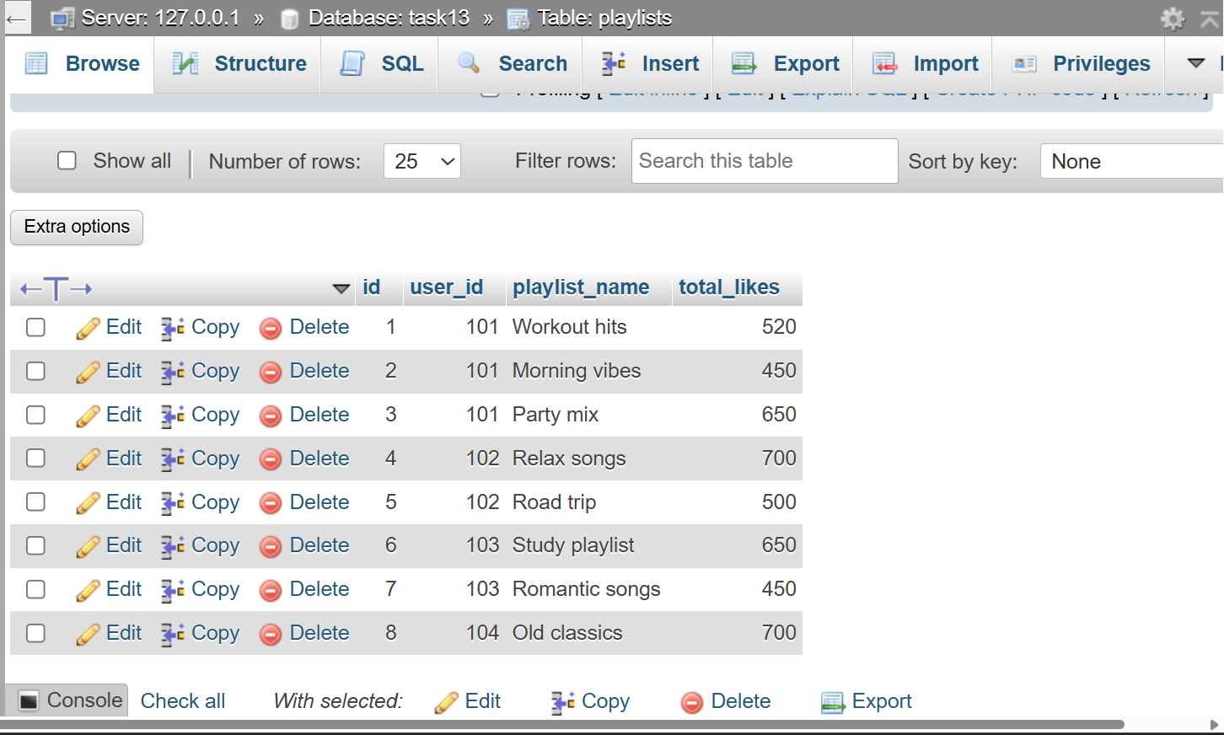
QUESTION : 2
Write a SQL query using ROW_NUMBER() and the OVER() clause to assign a unique row number to each playlist, ordered by total_likes in descending order :

SELECT id,playlist_name,user_id,total_likes,
ROW_NUMBER() OVER (ORDER BY total_likes DESC) AS row_num
FROM Playlists;

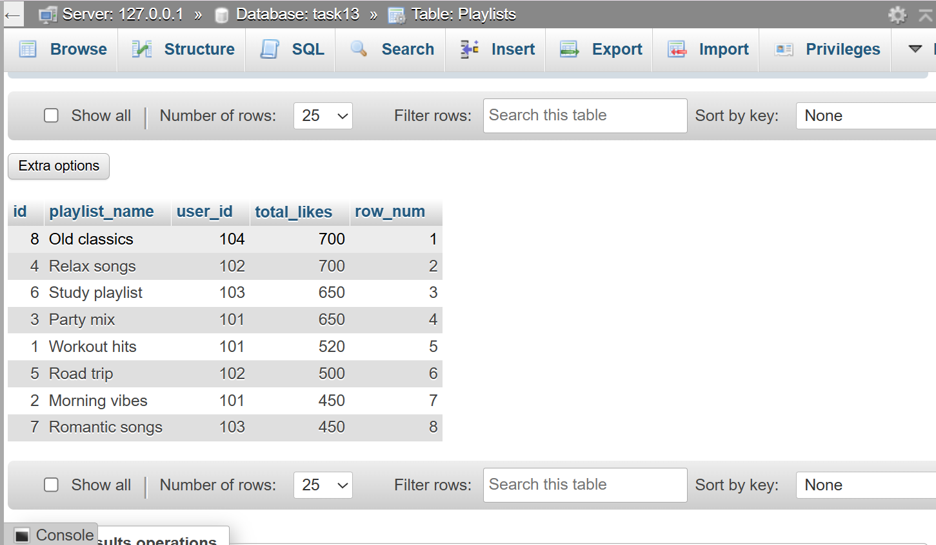
QUESTION : 3
Use the RANK() function with the OVER() clause to rank all playlists by total_likes, and display the playlist_name, user_id, total_likes, and their rank :

SELECT playlist_name,user_id,total_likes,
RANK() OVER(ORDER BY total_likes DESC) AS playlist_rank
FROM Playlists;

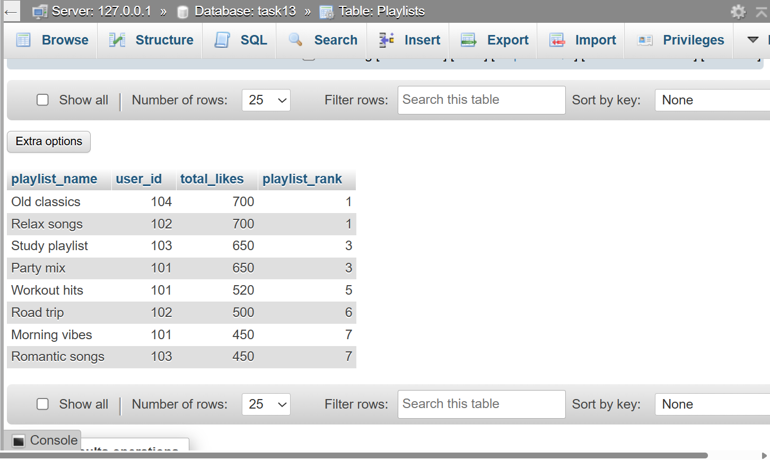
QUESTION : 4

Write a SQL query using DENSE_RANK() and PARTITION BY user_id to rank each user's playlists by total_likes, showing playlist_name, user_id, total_likes, and dense rank.<br><br><em><strong>Hint:</strong> This will show how popular each playlist is within each user's account, similar to how Spotify might rank your top playlists.</em> :

SELECT playlist_name,user_id,total_likes,
DENSE_RANK() OVER(PARTITION BY user_id ORDER BY total_likes DESC)AS dense_rank
FROM Playlists;

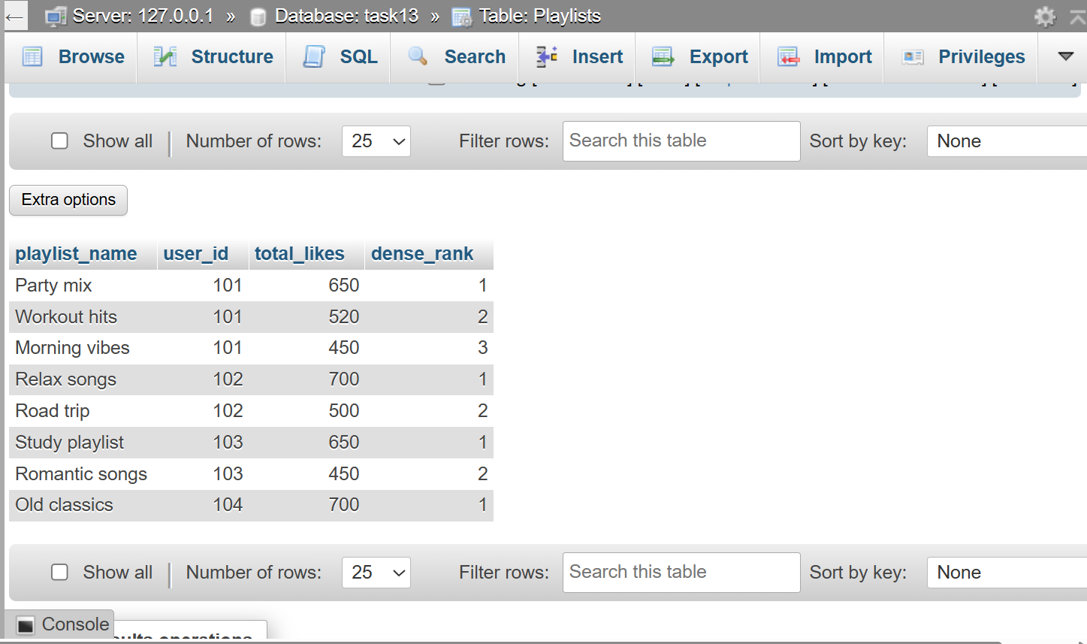
QUESTION : 5
Imagine you want to show the top 2 playlists per user based on total_likes, like Spotify's 'Your Top Playlists' feature. Write a query using a window function to select only the top 2 playlists for each user :

SELECT * FROM
(SELECT playlist_name,user_id,total_likes,ROW_NUMBER()
OVER(PARTITION BY user_id ORDER BY total_likes DESC)
AS Rank FROM Playlists) AS result WHERE Rank<=2;

